48th international exhibition
of Inventions Geneva
25-29 MARch 2020 – PALEXPO
ENTRY FORM
To be returned as soon as possible and not later than 17th February 2020 INTERNATIONAL EXHIBITION OF INVENTIONS
Palexpo SA - P.O. Box 112 - 1218 Le Grand-Saconnex / Geneva / Switzerland Tel. +41 (0)22 761 11 11 - Fax +41 (0)22 798 01 00
expo@inventions-geneva.ch - inventions-geneva.ch
REGISTRATION DEADLINE:
17th February 2020 After this date entry
fees will be increased by 10%
EXHIBITOR Companies / Organisms or private inventor
Name of the company / organism exhibiting .........................................................................................................................................................................

or
Exhibitor’s name (UNDERLINE FAMILY NAME) ........................................................................................................................................................................

Address ..............................................................................................................................................................................................................................

Post code ........................................................ Town or city ........................................................... Country ..........................................................

Telephone* ............................................................................................. Mobile* ........................................................................................................

E-mail* ................................................................................................... Website* ......................................................................................................

* Information that will be included in the catalogue.

INVENTION Description of your invention. 3 lines maximum (180 characters)
This information will be reproduced in the Official Exhibition Catalogue. (If possible, kindly provide French translation.)

...........................................................................................................................................................................................................................................

...........................................................................................................................................................................................................................................

...........................................................................................................................................................................................................................................

In wich class do you consider your invention should be placed (See classes indicated in art.4) .................................................................................................

Name to be displayed on the booth and in the catalogue .......................................................................................................................................................

If the Jury gives a prize to this invention, to whom should it be awarded? (Name on the diploma) .............................................................................................

...........................................................................................................................................................................................................................................

In what form do you intend to exhibit your invention? | ❑ Manufactured article | ❑ Prototype | ❑ Plan
Have you already applied for a patent for your invention? | ❑ YES ❑ NO
Is your invention protected by a patent? | ❑ YES ❑ NO
If not, what kind of protection does your invention have? ........................................................................................................................................................
If your invention is not protected, we do not guarantee acceptance of your registration.
For more information on Intellectual Protection, visit the WIPO website: www.wipo.int/portal/en/
What is the purpose of exhibiting your invention?

Find distributors?  Contact manufacturers? | ❑ YES  ❑ YES | ❑ NO  ❑ NO | Grant licences to manufacturers?  Grant licences to distributors? | ❑ YES  ❑ YES | ❑ NO  ❑ NO
Find a financial backer? | ❑ YES | ❑ NO | Sell your patent? | ❑ YES | ❑ NO

REGISTRATION FEE PER INVENTION EXHIBITED

If you wish to exhibit more than one invention, you must fill in one entry form per invention and a reduction of 10% will be granted on the total entry fees.

For private inventors whose invention is not yet commercialized | CHF 880.- | CHF .....................................
or or
For companies, private and State organisms and for private inventors who exhibit under a company name or whose patent is registered in the name of a company or whose invention is already commercialized | CHF 1’800.- | CHF .....................................
STAND RENTAL COSTS +
Please fill in details of the stand you require.

I order a stand of m2 surface (minimum 4 m2, that is 2 m x 2 m)  i.e. .......... m (minimum 2 m) length x m (minimum 2 m) depth  at the price of  including carpeting, a back wall 2.5 m high and lateral wall of 1 m wide x  2.5 m high on each side. | CHF 280.-/ sq. metre | CHF .....................................

Sub total  +VAT 7.7% | CHF .....................................  CHF .....................................
TOTAL AMOUNT PAYABLE FOR ENTRY FEES  comprised of registration fees plus stand rental costs and VAT Payable in CHF after receipt of invoice | CHF .....................................

Billing address if different than the exhibitor’s:

Surname, first name ............................................................................................................................................................................................................

Address ..............................................................................................................................................................................................................................

E-mail .................................................................................................... Telephone ....................................................................................................

I, the undersigned agree to abide by all points regulations in this Entry Form, in particular point 8, as well as the exhibition regulations.

Date ....................................................................................................... Signature .....................................................................................................

If you require a special stand just send us a sketch showing measurements and where you require walls. We will send you an offer.

HOW TO EXHIBIT YOUR INVENTION

Your invention can be exhibited as :
- a pre-series sample
- a commercial sample
- a prototype
- a model
- a plan, drawing, photo or descriptive text

We shall place on your stand :
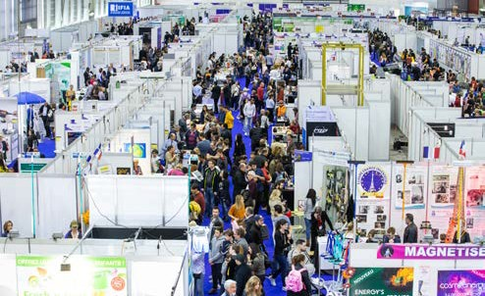
- a notice (measuring 65 X 15 cm) placed above your invention, giving your name and nationality
- a technical notice (measuring 21 x 17 cm) giving a brief description of your invention in English and French

If you want us to supply furniture, or electric current on your stand, please contact us at:
inventions-geneva.ch
+41 (0)22 761 11 11
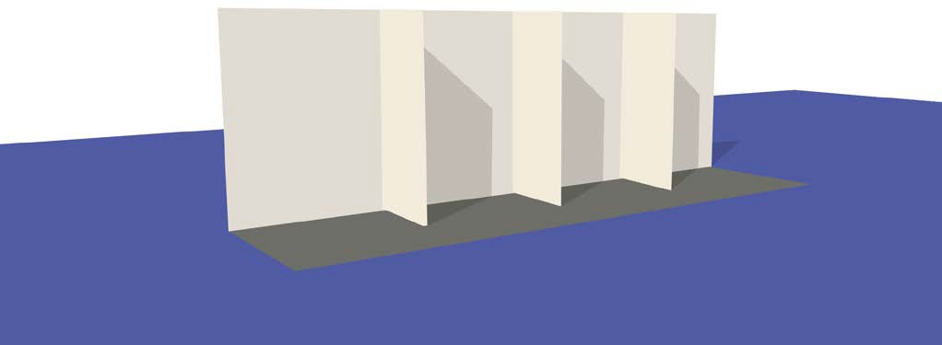expo@inventions-geneva.ch
Lateral separation wall(s), 1 m wide
white, Syma system, 7 mm thick
Light grey carpeting
Back wall
white, Syma system 7 mm thick
STAND WITH BACK WALL, lateral wall of 1m on each side AND CARPETING
The inventions are exhibited side by side on stands with a back wall 2,5 m. high.
Please indicate the dimensions of the stand you require on the entry form under “STAND RENTAL COSTS”.
THIS PAGE IS TO BE RETAINED BY THE EXHIBITOR

Services of the team of interpreters / hostesses to help you communicate with foreign visitors

Back wall 2.50 m high

THIS PAGE IS TO BE RETAINED BY THE EXHIBITOR

ADVERTISING
WHETHER YOU WISH TO EXHIBIT OR NOT, WHY NOT RESERVE ADVERTISING SPACE IN THE OFFICIAL EXHIBITION CATALOGUE?
The rates for 1 page, ½ page ou ¼ page advertisements will be sent to you or see inventions-geneva.ch.
The Official Catalogue is diffused throughout the world.

- The International Exhibition of Inventions of Geneva is open to: inventors, companies, firms, promoters, associations, universities, private and state organizations, showing inventions already protected by intellectual property rights.
- An invention may only be presented once at the Exhibition in Geneva, unless substantial modifications have been made to it since it was first exhibited.
- Inventions may be presented in the form of pre-series or commercial samples, already manufactured articles, prototypes, models, plans, drawings, photos and texts.
- In the Official Catalogue, the inventions will be published in one of the following classes and the Committee alone shall decide in which classes they shall be placed.
- The inventions exhibited will be grouped by country. Exhibitors must indicate on the entry form the kind of stand they will need.
Stands will be sited by the Committee.
- SALE TO OUR VISITORS
Exhibitors may not sell products or articles directly to visitors. However, sale of products or articles is authorized in a special section of the Exhibition. For information, apply to the Secretariat.
- Exhibitors must complete A SEPARATE ENTRY FORM FOR EACH INVENTION WHICH THEY WISH TO EXHIBIT. Not more than one invention may be included on each form. Entry forms, duly completed and signed, should be sent as soon as possible and before the deadline to the Secretariat. After this date, subject to places still being available, entry fees will be increased by 10%.
- Once the Entry Form has been accepted and registration con- firmed by the Committee to the exhibitor, the exhibitor is obliged to pay the total amount of his/her invoice within the delay indicated. Exhibitors who cancel their participation before the last registration date must pay 50% of their invoice. Exhibitors who cancel their participation after the last registration date must pay the whole amount of their invoice.
Class | A | Mechanics - Engines - Machinery - Tools -  Industrial processes - Metallurgy
Class | B | Watchmaking - Jewellery- Machinery - Tools
Class | C | Computer sciences - Software - Electronics - Electricity - Methods of communication
Class | D | Building - Architecture - Civil Engineering - Construction  - Materials - Woodwork
Class | E | Sanitation - Ventilation - Heating
Class | F | Security - Rescue - Alarm
Class | G | Ironmongery - Do-It-Yourself
Class | H | Furnishing - Interior architecture
Class | I | Domestic science - Restaurant equipment
Class | J | Commercial, industrial and office equipment
Class | K | Agriculture - Horticulture - Gardening
Class | L | Clothing - Textiles - Machines and accessories
Class | M | Medicine - Surgery - Orthopaedics - Material for disabled
Class | N | Optics - Photography - Cinematography - Eyewear
Class | O | Teaching methods and materials - Musical instruments - Art materials
Class | P | Transport - Motor vehicles - Ships - Aviation - Accessories
Class | Q | Paramedical - Health - Hygiene - Foodstuffs - Drinks - Cosmetics
Class | R | Sport - Leisure
Class | S | Practical novelties - Presents
Class | T | Publicity - Printing - Packaging
Class | U | Games - Toys
Class | V | Protection of the environment - Energy

- Exhibitors requiring an electricity supply, furniture, parking or advertising space in the Official Catalogue must submit their requests on the special forms which will be forwarded to them within the deadline and are on
inventions-geneva.ch.

GENERAL INSTRUCTIONS
After receipt of the Entry Form, the Committee will send to each exhibitor the General Instructions concerning:
  - the dates for building and dismantling the stands
  - how to send and/or transport the inventions
  - the official opening ceremony of the Exhibition
  - the day on which the International Jury examines each invention
  - the prize-giving ceremony
- The Committee accepts no responsibility for any errors in the translation or wording of descriptions and advertisements published in the Official Catalogue.
- A security service will operate during the whole period of the Exhibition. However, the Organizing Committee and its representatives abroad accept no responsibility for loss, theft, damage due to fire or other causes, or personal injury suffered, during the Exhibition or in transit.
- By his formal application to participate in the Exhibition, each exhibitor undertakes to ensure delivery of his invention at the time stated in the instructions he receives and to allow it to remain on display during the whole Exhibition. Any exhibitor withdrawing his invention before closure shall render himself liable to pay damages and shall forfeit any award made to him.
The Committee of the International Exhibition of Inventions of Geneva

Organisation: INTERNATIONAL EXHIBITION OF INVENTIONS
Palexpo SA • P.O. Box 112 • 1218 Le Grand-Saconnex • Geneva • Switzerland
T +41 (0)22 761 11 11 • F +41 (0)22 798 01 00 • expo@inventions-geneva.ch - inventions-geneva.ch

